* Case syntax:

**package** switchCase;

**public** **class** Test {

**public** **static** **void** main(String[] args) {

**int** day=3;

**switch**(day) {

**case** 1:

System.***out***.println("Monday");

**case** 2:

System.***out***.println("Tuesday");

**case** 3:

System.***out***.println("Wednesday");

**case** 4:

System.***out***.println("Thursday");

**case** 5:

System.***out***.println("Friday");

**case** 6:

System.***out***.println("Saturday");

**case** 7:

System.***out***.println("Sunday");

}

}

}

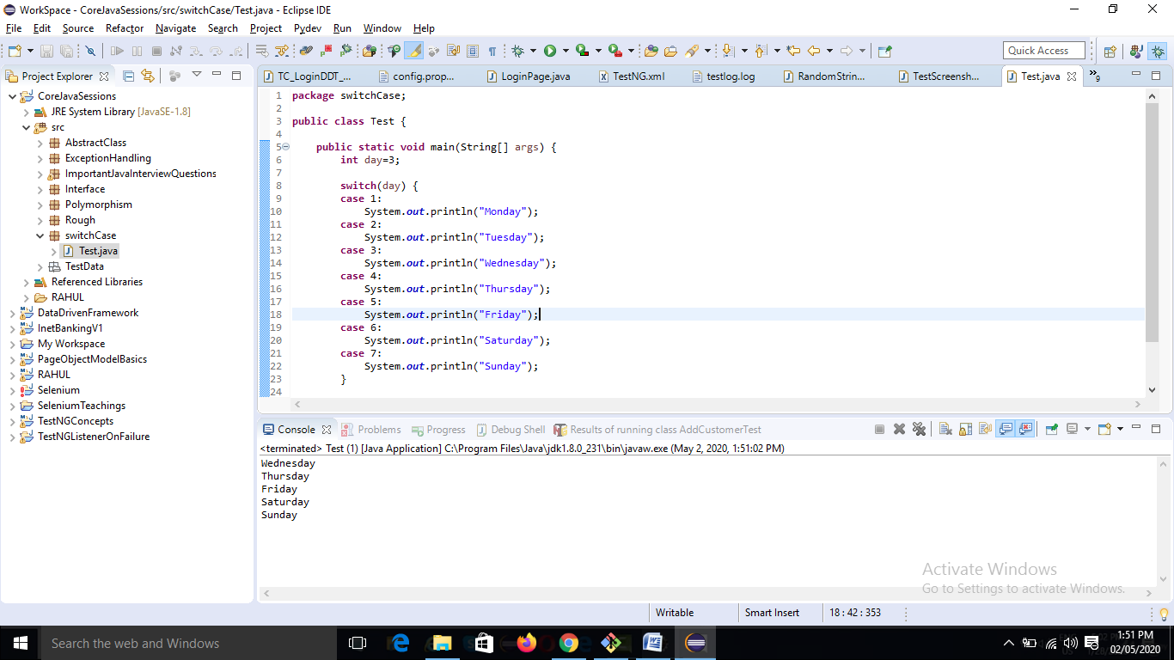

* Datatype should be same. We cannot write

Case “eight”:

* Same thing we can do using if-else; but switch is faster than if-else. It is more optimized.
* Unlike if-else, switch will directly jump onto the mentioned case.
* The only issue with switch case is that if we consider it as 3 along with it rest will also be printed which is after that particular case irrespective of the case is satisfied or not. So we need to write break statement after each case.
* If we want only 3rd case to be executed, we need to add a break statement. (after each case)
* We can have multiple statements also under a case.

Eg:

**case** 3:

System.***out***.println("Wednesday");

System.***out***.println("It is the third day");

System.***out***.println("Only this to be printed");

* Like if else, here we can add curly braces as well. If not then also its fine.

Eg:

**case** 3:{

System.***out***.println("Wednesday");

System.***out***.println("It is the third day");

System.***out***.println("Only this to be printed");

}

* Following will break the case:

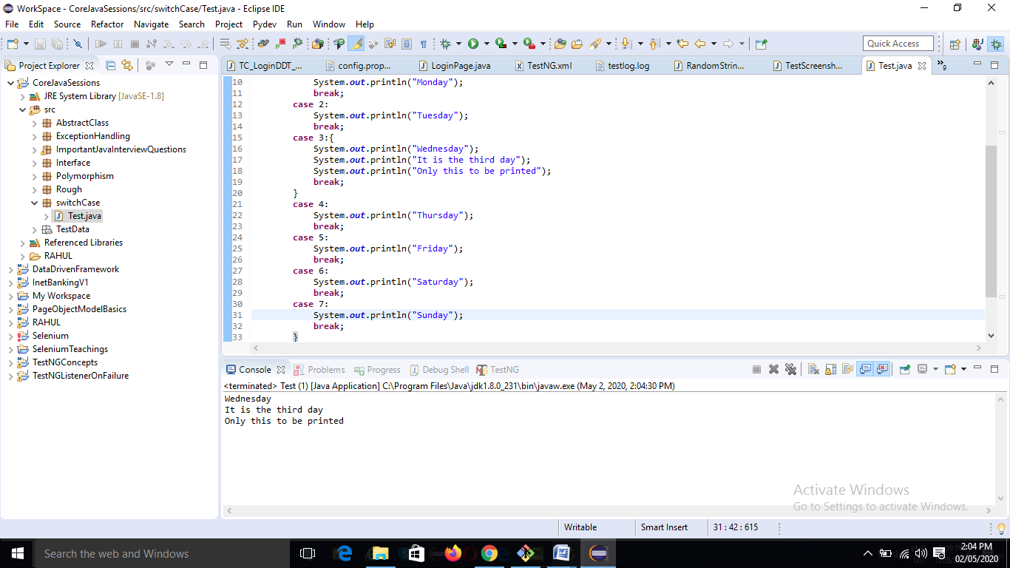

**package** switchCase;

**public** **class** Test {

**public** **static** **void** main(String[] args) {

**int** day=3;

**switch**(day) {

**case** 1:

System.***out***.println("Monday");

**break**;

**case** 2:

System.***out***.println("Tuesday");

**break**;

**case** 3:{

System.***out***.println("Wednesday");

System.***out***.println("It is the third day");

System.***out***.println("Only this to be printed");

**break**;

}

**case** 4:

System.***out***.println("Thursday");

**break**;

**case** 5:

System.***out***.println("Friday");

**break**;

**case** 6:

System.***out***.println("Saturday");

**break**;

**case** 7:

System.***out***.println("Sunday");

**break**;

}

}

}

Output:

Wednesday

It is the third day

Only this to be printed

* What will be the output?

**public** **static** **void** main(String[] args) {

**int** day=3;

**switch**(day) {

**case** 1:

System.***out***.println("Monday");

**break**;

**case** 2:

System.***out***.println("Tuesday");

**break**;

**case** 3:{

System.***out***.println("Wednesday");

System.***out***.println("It is the third day");

System.***out***.println("Only this to be printed");

}

**case** 4:

System.***out***.println("Thursday");

**break**;

**case** 5:

System.***out***.println("Friday");

**break**;

**case** 6:

System.***out***.println("Saturday");

**break**;

**case** 7:

System.***out***.println("Sunday");

**break**;

}

}

Output:

Wednesday

It is the third day

Only this to be printed

Thursday

Note: Wherever break is there, from there break will be effective.

* So we have to use break at the end of each case.
* We can add a default case for the case which is not present.

Eg:

**public** **static** **void** main(String[] args) {

**int** day = 8;

**switch** (day) {

**case** 1:

System.***out***.println("Monday");

**break**;

**case** 2:

System.***out***.println("Tuesday");

**break**;

**case** 3: {

System.***out***.println("Wednesday");

System.***out***.println("It is the third day");

System.***out***.println("Only this to be printed");

**break**;

}

**case** 4:

System.***out***.println("Thursday");

**break**;

**case** 5:

System.***out***.println("Friday");

**break**;

**case** 6:

System.***out***.println("Saturday");

**break**;

**case** 7:

System.***out***.println("Sunday");

**break**;

**default**:

System.***out***.println("No Case Matched!!");

}

}

Output:

No Case Matched!!

* Yo can add the default at the beginning as well:

**switch** (day) {

**default**:

System.***out***.println("No Case Matched!!");

**case** 1:

System.***out***.println("Monday");

**break**;

**}**

In this case we will have to add a break statement after default also.

**switch** (day) {

**default**:

System.***out***.println("No Case Matched!!");

**break**;

**case** 1:

System.***out***.println("Monday");

**break**;

**}**

if at the end, then break is not required.

*******